**Quick Guide to Install, Setup and Run OBS Studio for Recording purposes**

* *Installing*

. Go to the official OBS Studio website (<https://obsproject.com/>)

. Choose your Operating System on the home page (Windows, macOS 10.13+, Linux)

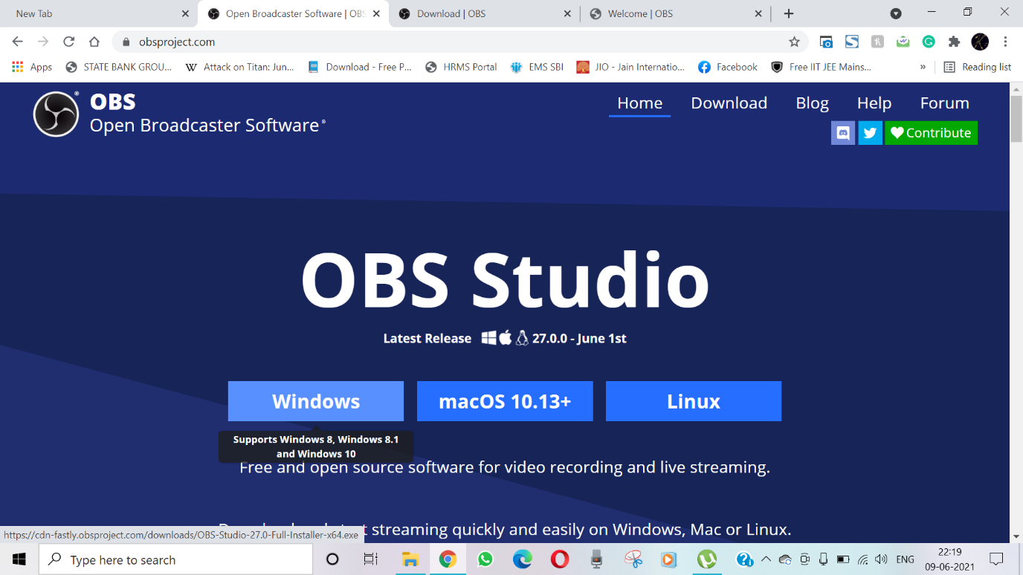

. After choosing the suitable Operating system, the setup would start downloading automatically once you click ‘’Save” option

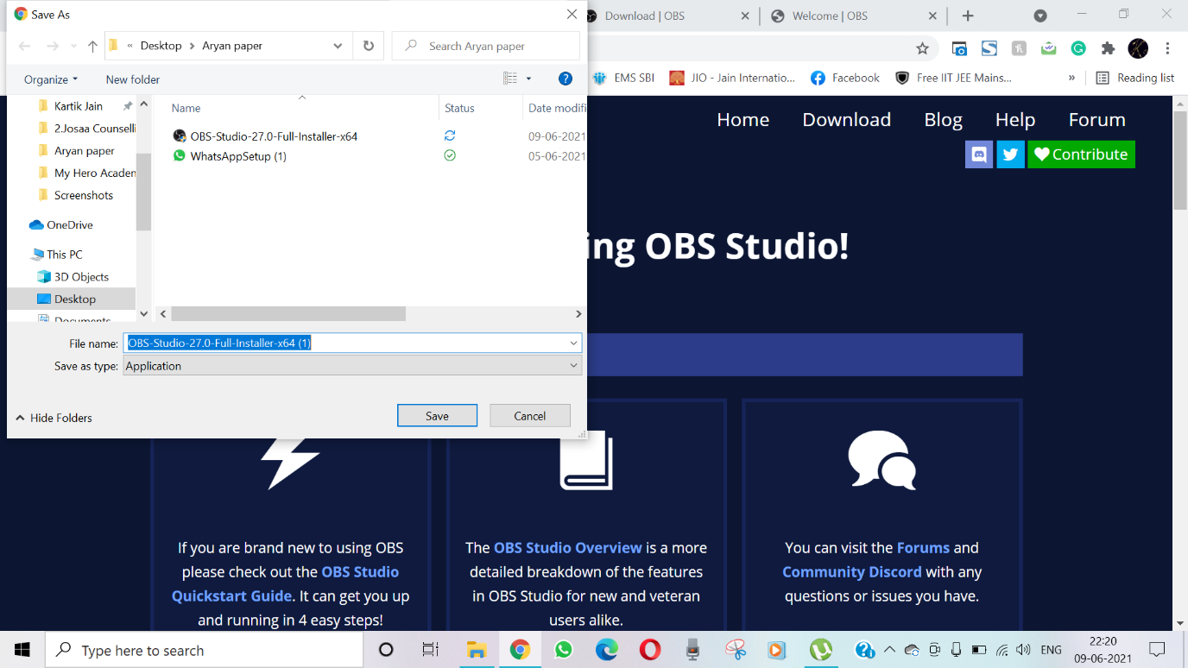

. Once the download is finished, Install the files and open the OBS Studio

* *Setup*

Once you open the application, a dialogue box will appear “Auto-Configuration Wizard” and will ask your preferences on your need from the program. These preferences can be changed later in “Tools” option.

Choose “Optimize just for recording, I will not be streaming ” to begin with

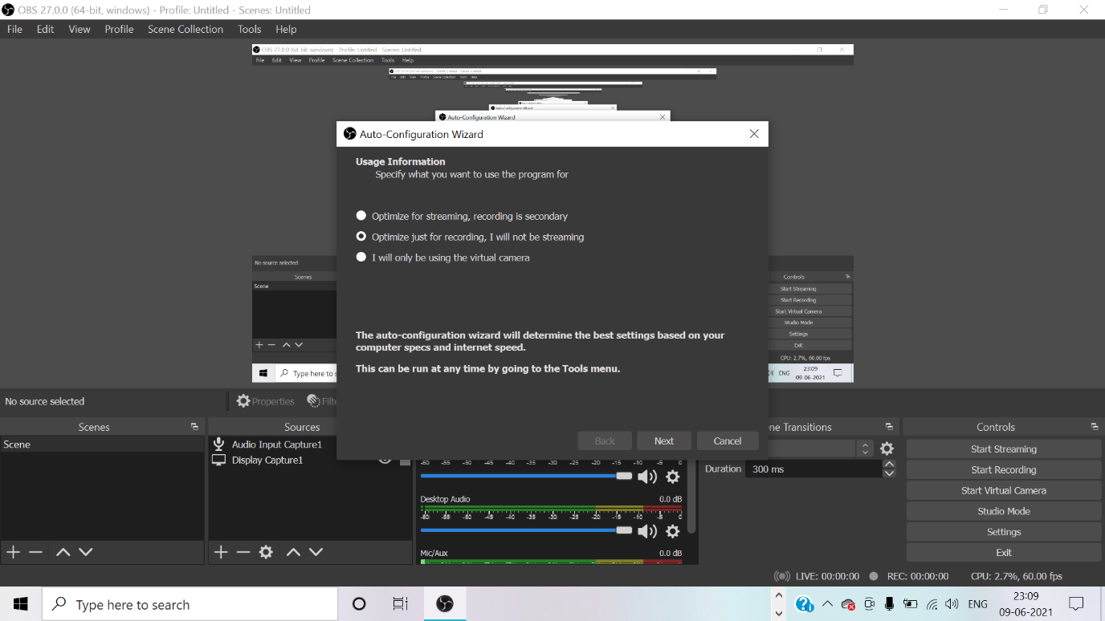

. Click on “Next” and it will ask for “Vide Settings” which you can keep as “Base(Canvas) Resolution- Use current (1920x1080)”, “FPS- Either 60 or 30 but prefer 60 when possible”

. Cick “Next ” and you will see that “Auto Configuration Wizard” has chosen best setting for your system.

. Click on “Apply Settings”.

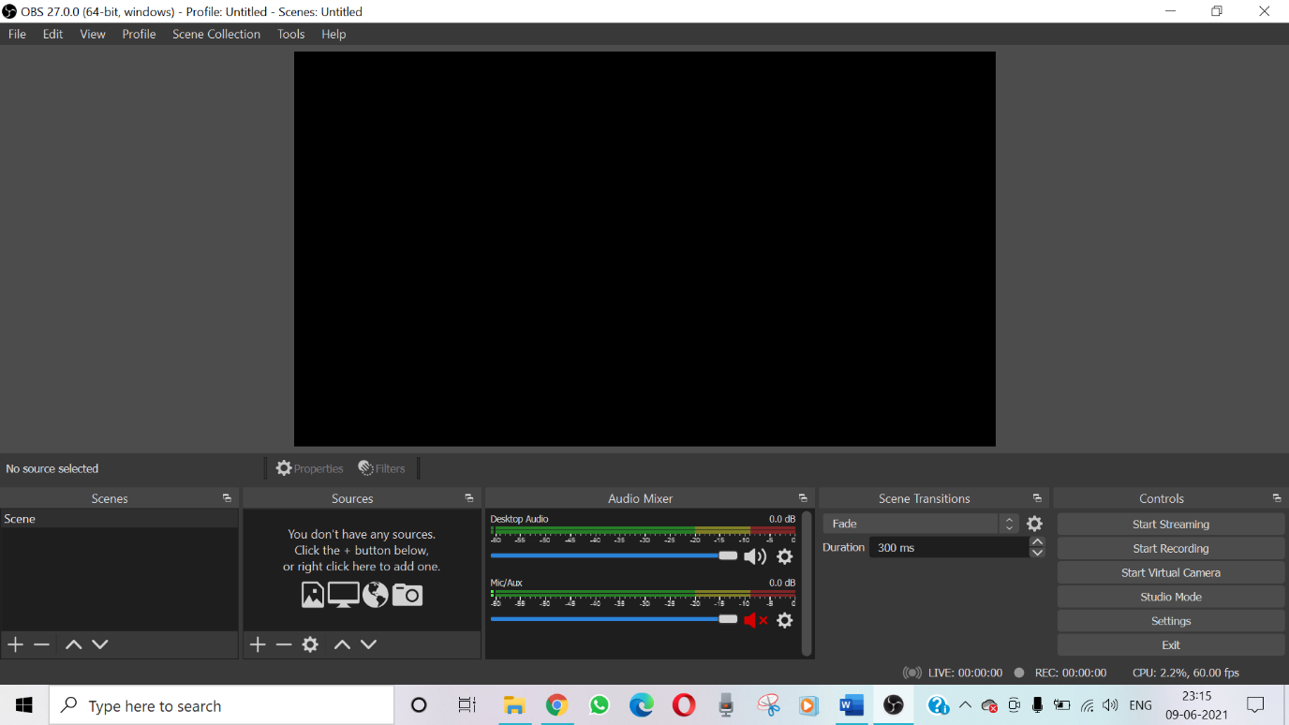

. You will see such a setup with a black screen in middle.

. Now choose sources for Display and Input Audio.

. For doing this, see the “Source” option on the bottom of the application and click on the “+” option.

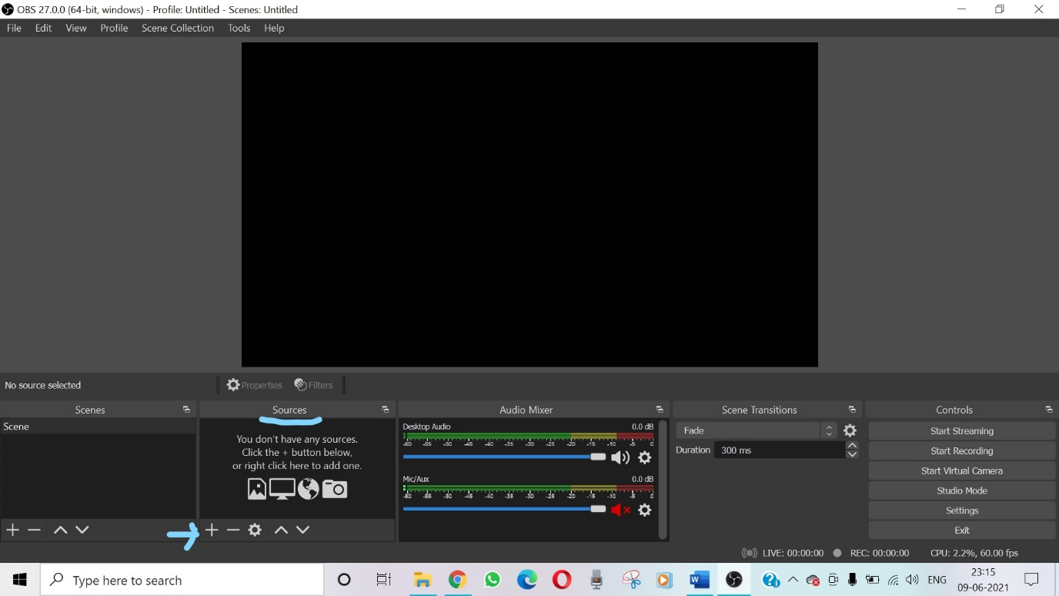

. From here you need to add source for Audio and Video.

. Click on “Audio Input Capture” > “Add Existing” > “Mic/Aux” > “OK”.

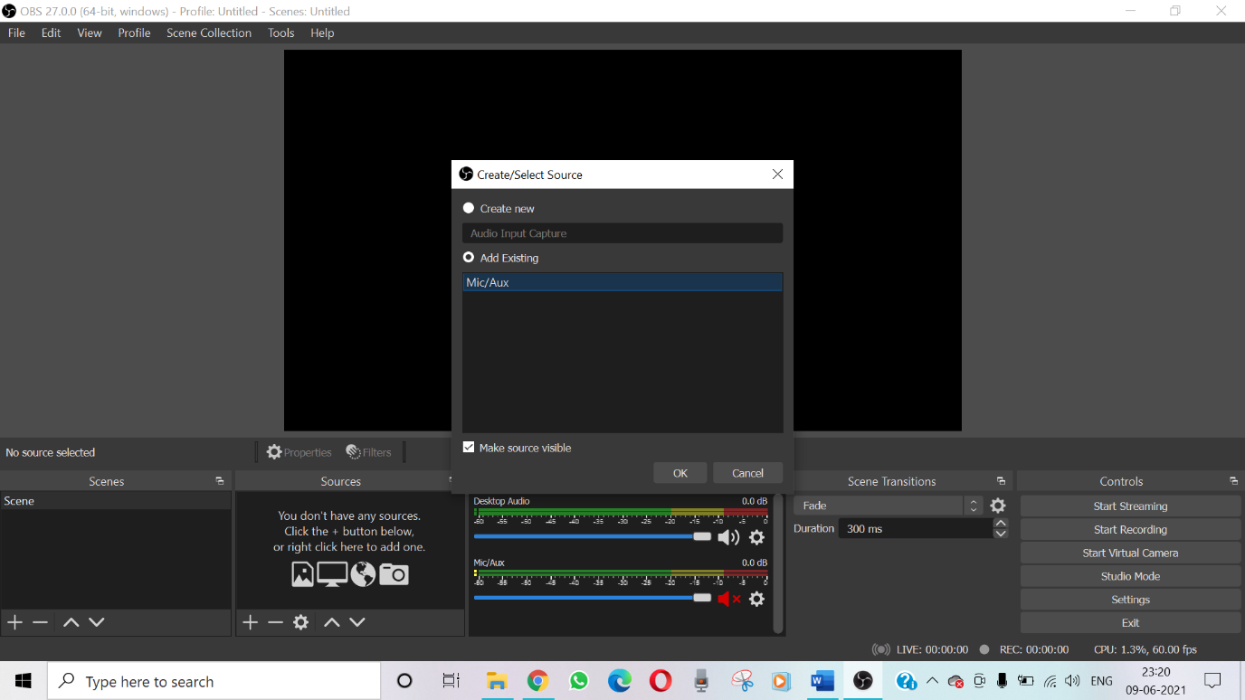

. Click on “Display Capture” > “Create New” (name it, e.g ‘Display Capture1’) > “OK”.

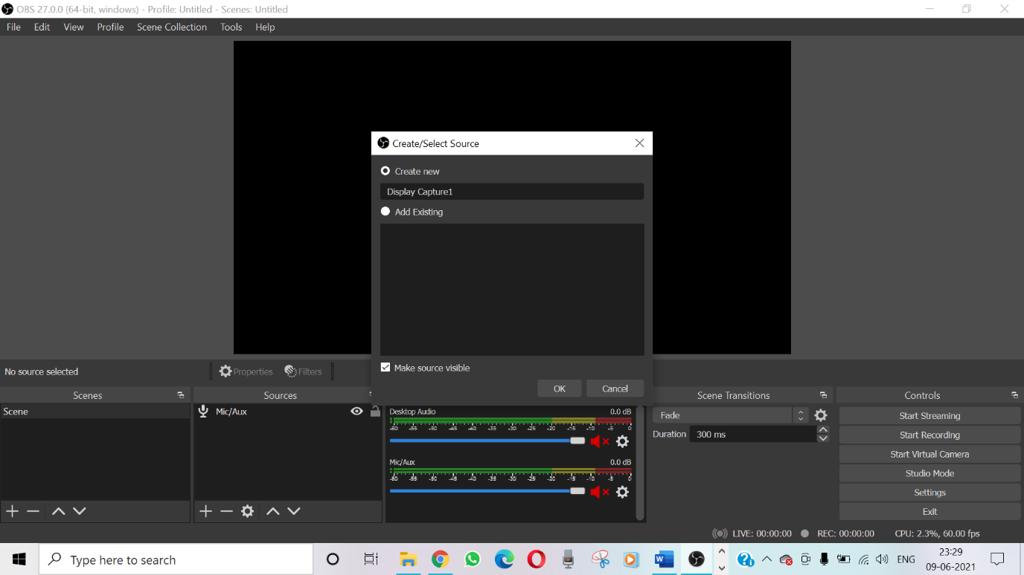

. Finally you will see a screen like this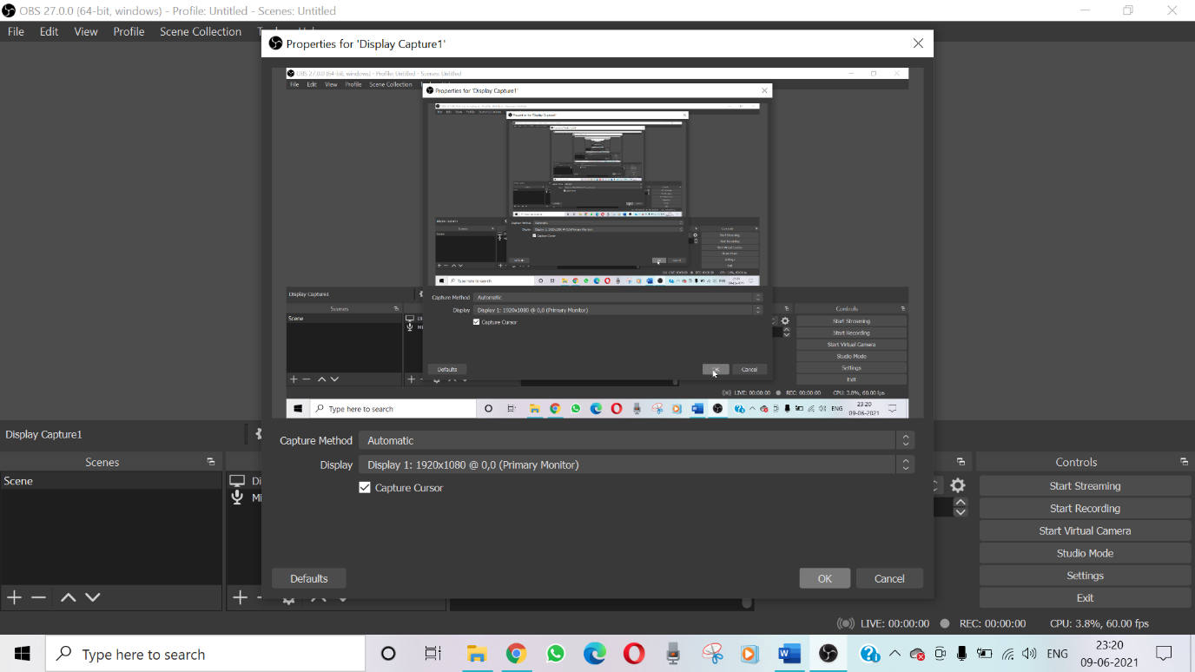

. Click “OK”

* *Recording*

. See in the “Audio Mixer” option, if any audio is on mute, turn it on.

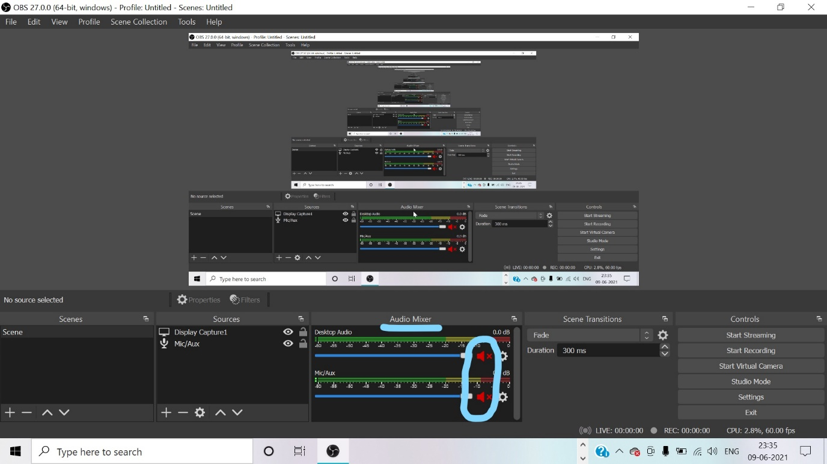

. Click on the “Start Recording” option in the ‘bottom-right corner’ under “Controls”.

Your recording has started which will record your screen, record any voice from your devide like music and record your voice.

. Once you have completed the recording, click on the “Stop Recording” present at the same place.

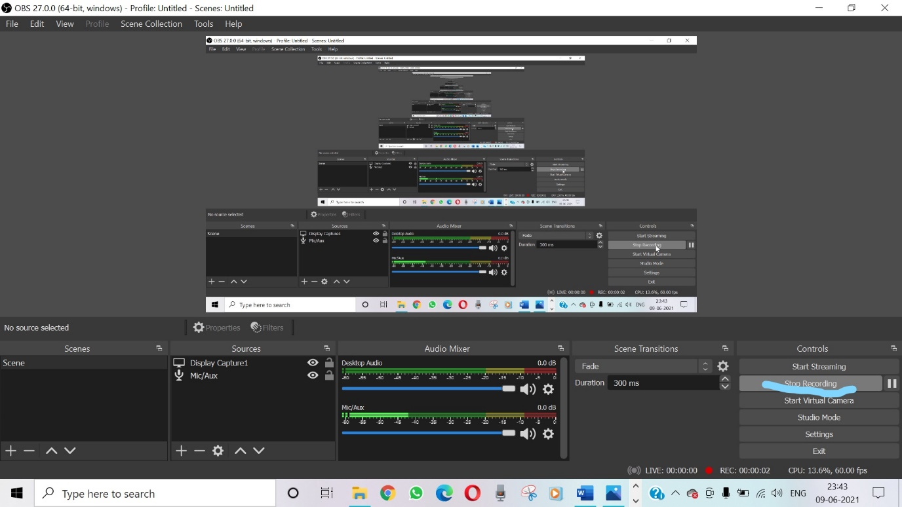

Your file will be saved and you can see the saved file in “File” > “Show Recordings” and change the file location “File” > “Setting” > “Output” > “Recording Path” > “Browse”.